Steps

1. Download Node.js from ‘https://nodejs.org/en/download/’.
2. Install Node.js

Node JS Installed in machine

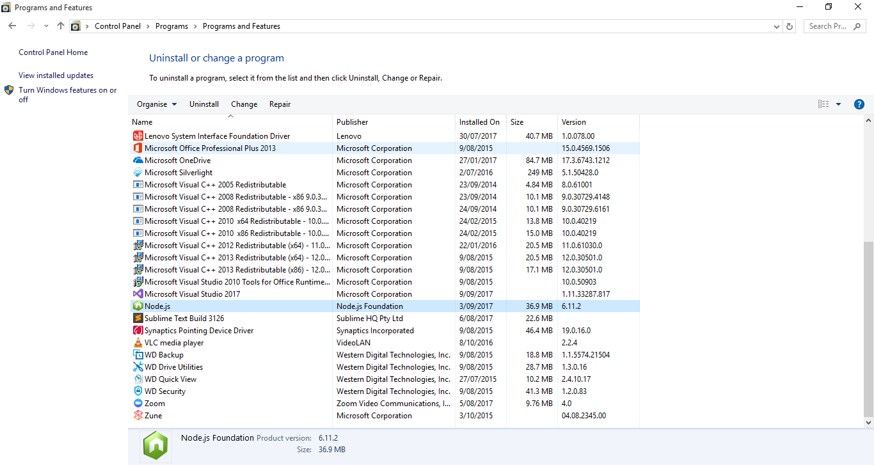

1. Check for Node and NPM if installed properly and also the version installed using the command prompt.

